UDP Overview:
UDP is the abbreviation of User Datagram Protocol. UDP makes use of Internet Protocol of the TCP/IP suit. In communications using UDP, a client program sends a message packet to a destination server wherein the destination server also runs on UDP.
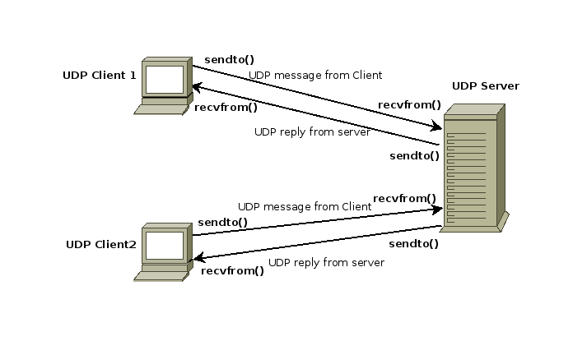

Properties of UDP:
- The UDP does not provide guaranteed delivery of message packets. If for some issue in a network if a packet is lost it could be lost forever.
- Since there is no guarantee of assured delivery of messages, UDP is considered an unreliable protocol.
- The underlying mechanisms that implement UDP involve no connection-based communication. There is no streaming of data between a UDP server or and an UDP Client.
- An UDP client can send "n" number of distinct packets to an UDP server and it could also receive "n" number of distinct packets as replies from the UDP server.
- Since UDP is connectionless protocol the overhead involved in UDP is less compared to a connection based protocol like TCP.
